**Spring 2020- CSE1142 Computer Programming II**

**Homework #5**

**Merve Rana Kızıl- 150119825**

The given input file was read, and the linked list was created. Linked list can be written to an output file.

insertNode function was written to insert a new node at the end of the linked list. A menu was created to take an input from user. printList function was written to print the content of the linked list based on four different orderings.

Sample screenshots for creating menu, inserting node, and printing linked list are given below.

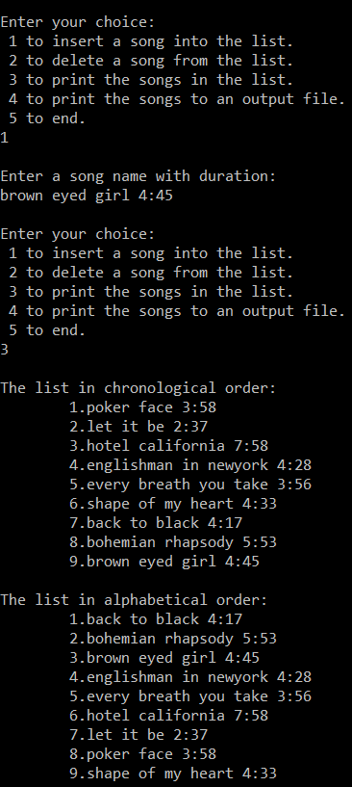

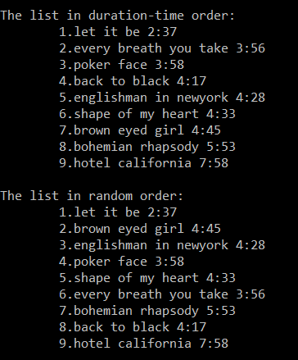

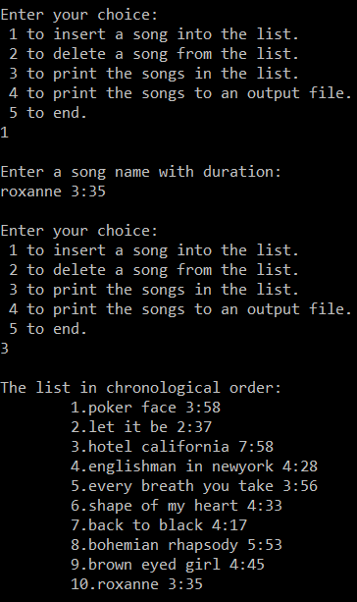

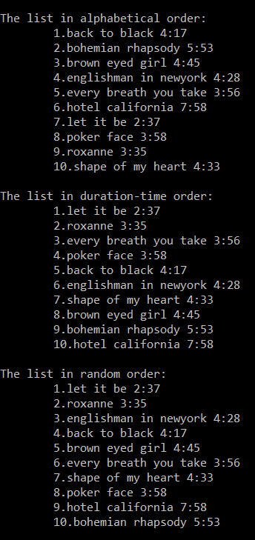

deleteNode function was written to delete an existing song from the list. Sample screenshot for deleting node is given below.

